   
**Version 25.1.0 for year 2025**

**Table of Contents**

1. Summary 1

2. Component Overview 1

2.1 Functional Overview 1

2.2 Use Cases 1

2.3 Compatibility 1

2.4 Privacy, Payment 1

2.5 Limitations, Constraints 1

3. Implementation Guide 1

3.1 Setup 1

3.2 Configuration 2

3.2.1 Installing the cartridge(s) 2

3.3 Custom Code 3

4. Operations, Maintenance 3

4.1 Failure/Recovery Process 3

4.2 Support 3

5. Known Issues/Caveats 4

6. Release History 4

# Summary

This document provides the guidelines for the implementation of the Noibu StoreFront Reference Architecture (SFRA) enabled cartridge to SalesForce Commerce Cloud (SFCC).

This document describes how the Noibu cartridge works.

# Component Overview

## Functional Overview

This cartridge is designed to facilitate integration with Noibu for session tracking and management. Its primary functionality revolves around sending the session ID to Noibu for enhanced session monitoring and analysis. This integration ensures that Noibu can effectively capture and process user interactions, enabling detailed insights into the customer journey.

Additionally, this cartridge is built to streamline processes while maintaining compatibility with Noibu's analytics ecosystem. Although the focus is currently limited to session ID tracking, the architecture supports potential future enhancements, such as capturing additional user metadata or interaction events

## Compatibility

Compatibility mode: 7.0.1

## Privacy, Payment

There are currently no privacy or payment issues.

## Limitations, Constraints

There are no known limitations or constraints.

# Implementation Guide

## Setup

The following Noibu Integration tasks are included within the LINK Cartridge:

1. Installation of the cartridge
2. Import custom metadata
3. Set the newly-created metadata values (Site Preferences)

## Configuration

## Installing the cartridge(s)

* **Import the link_noibu cartridge into the Commerce Cloud Studio Workspace:**

Open Commerce Cloud Studio

Click File -> Import -> General -> Existing Projects Into Workspace

Browse to the “link_noibu” directory

Click Finish.

Click OK when prompted to link the cartridge to the sandbox

* **Assign cartridge to site**  
  Log into Business Manager  
  Click Administration -> Sites -> Manage Sites -> RefArch or the required site  
  Select the “Settings” tab  
  Add “int_noibu:int_noibu_sfra_changes” to the beginning of the cartridge path (or ensure it is in front of app_storefront_base  
  Click Apply

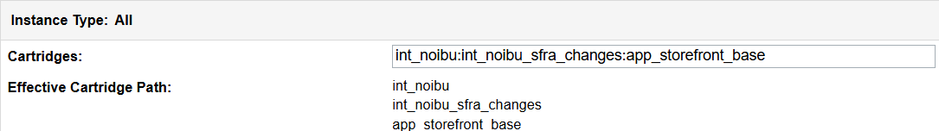

* Click [Administration](https://dev01-na01-luxurybrandholdings.demandware.net/on/demandware.store/Sites-Site/default/ViewApplication-ExpandMenuGroup?MenuGroupID=AdministrationMenu&OverviewPage=SiteNavigationBar-ShowAdministrationOverview&csrf_token=gV0CPCPqzbUWM_Y7xLVOkzpmo1l3wBw25A_Jz3QemO2H3jn8SJgyYhC_-ULx9nuKFeGuted4OXcL_RAmnAplrdfg2nnyEvQR6hx-Elu8uxJwk064aB-RYaggWSSrZDjOvpBYk7RSPYGp-EOqraLoaTVAZM5p7KUjiIV0JHwNeYZL4l_iaRw) > [Site Development](https://dev01-na01-luxurybrandholdings.demandware.net/on/demandware.store/Sites-Site/default/SiteNavigationBar-ShowMenuitemOverview?CurrentMenuItemId=studio&csrf_token=gV0CPCPqzbUWM_Y7xLVOkzpmo1l3wBw25A_Jz3QemO2H3jn8SJgyYhC_-ULx9nuKFeGuted4OXcL_RAmnAplrdfg2nnyEvQR6hx-Elu8uxJwk064aB-RYaggWSSrZDjOvpBYk7RSPYGp-EOqraLoaTVAZM5p7KUjiIV0JHwNeYZL4l_iaRw) > Code Deployment if a different code version is already active, switch to the desired code version and click Activate.
  + 1. **Configure Noibu preferences**

In Business Manager, navigate to the target Site > Site Preferences > Custom Preferences.

A custom site preference group with the ID **noibuConfigurations** is available. Please select it and edit the attributes accordingly.

| **Preference Name** | **Description** |
| --- | --- |
| Noibu Enabled | Enabling Noibu will allow the cartridge functionality to proceed. |

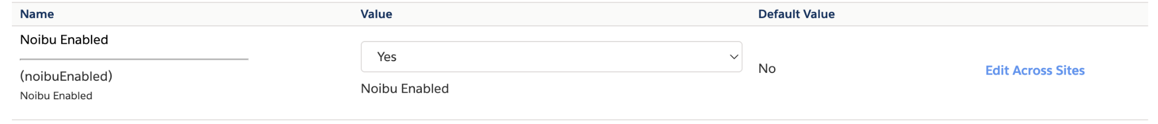

## Custom Code

The “int_noibu_sfra_changes” cartridge includes example template changes to integrate Noibu functionality. These will work with a default SFRA installation but may need to be merged into your cartridge(s) if you have customized the same templates.

* + 1. Please see “int_noibu_sfra_changes\cartridge\templates\default\common\htmlHead.isml” for the changes in template. Override the highlighted snippet code into your overridden “app_storefront_base” cartridge’s “htmlHead.isml” template.



* + 1. Please see “int_noibu\cartridge\scripts\hooks\htmlHead.js”. where we have extended the htmlHead hook.
    2. Please see “link_noibu/cartridges/int_noibu/cartridge/templates/default/noibu/include/noibuInclude.isml”, line no 4 in order to set a data attribute

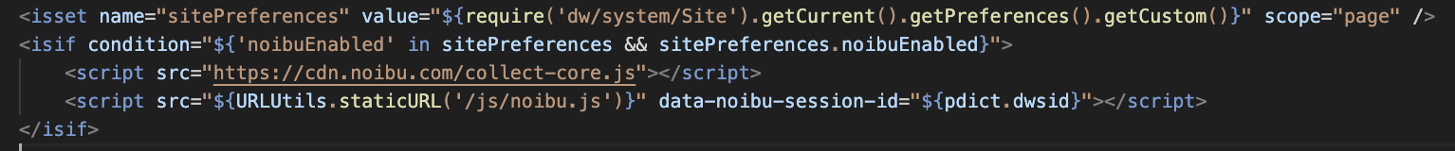

* + 1. Please see “link_noibu/cartridges/int_noibu/cartridge/client/default/js/noibu.js” line no 23 to get the data attribute which was initialzed in the above template



* + 1. Please see “link_noibu/cartridges/int_noibu/cartridge/client/default/js/noibu.js” line no 30 in order to send the custom attribute to Noibu. You may need to connect with Noibu to sync the attribute into the system.

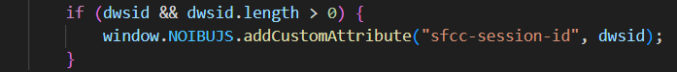

# Operations, Maintenance

## Failure/Recovery Process

When the cartridge is down this will not affect the functionality of the storefront, and the storefront will continue to operate as expected.

## Support

For post-live support, please contact Noibu at [support@noibu.com](mailto:support@noibu.com).

# Known Issues/Caveats

* *There are no known issues.*

# Release History

| **Version** | **Date** |
| --- | --- |
| 25.1.0 | 2025 |